REGINALD HUDLIN
Executive Producer

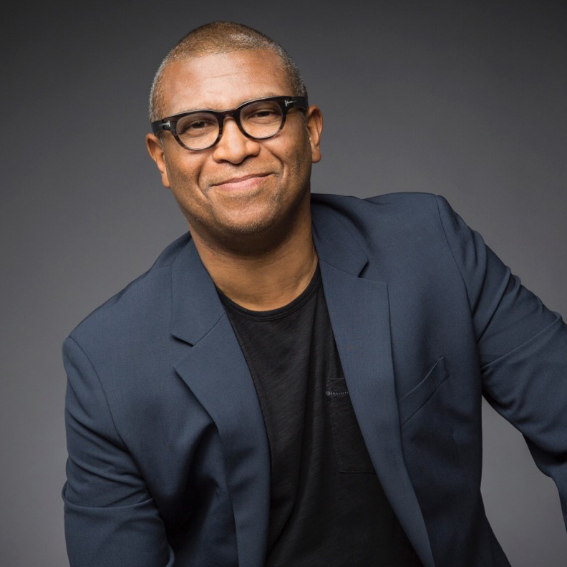

Oscar and Emmy nominated producer and director Reginald Hudlin is one of the most influential filmmakers of his generation.

Hudlin’s next film is SAFETY, a sports drama for Disney Plus that is currently in post-production and debuts on Christmas Day 2020.

His latest film, THE BLACK GODFATHER, is an award-winning documentary currently streaming on Netflix. He also recently directed the legal thriller MARSHALL, starring Chadwick Boseman as Thurgood Marshall, with Josh Gad, Kate Hudson, and Sterling K. Brown.

Hudlin is the producer of EMPEROR, a Civil War-era historical drama, which will premiere August 18, 2020 and stars Dayo Okeniyi, James Cromwell and Kat Graham.
Hudlin the first African American to executive produce the Emmys, which will air on September 20th of 2020.

In February 2016, Hudlin produced The Oscars, for which he subsequently received an Emmy nomination. Additionally, he has been the executive producer of the NAACP Image Awards for the past seven years.

In 2012, he was nominated for a Best Picture Academy Award as one of the producers of Quentin Tarantino’s Academy Award and Golden Globe-winning film DJANGO UNCHAINED, which is one of the top-grossing Westerns of all time.

In his illustrious career, Hudlin has written, directed and/or produced numerous popular feature films including HOUSE PARTY, BOOMERANG, GREAT WHITE HYPE and BEBE’S KIDS. In television he was an executive producer of THE BOONDOCKS and wrote and produced THE BLACK PANTHER animated series based on the comic book series he wrote for 4 years.
Hudlin is one of the few filmmakers to also run a major media company. He was the first president of entertainment for Black Entertainment Television, the biggest black media company in the world. He created B.E.T.’s first full slate of original shows and an award winning news division.

Hudlin has been honored by the NAACP, The American Civil Liberties Union, The United Negro College Fund, The Sundance Film Festival, The American Film Institute, The San Diego Comic Con, The African American Film Critics Association, and many more venerable organizations.

